**Tugas Praktikum Pemrograman**

Nama: Kenji Ratanaputra  
NIM : 24/534421/PA/22664

Prodi : Ilmu Komputer

Pertemuan: 2

**Source Code:** [**https://github.com/Kenzi-R/Praktikum-Pemrograman/tree/main/Pertemuan%202**](https://github.com/Kenzi-R/Praktikum-Pemrograman/tree/main/Pertemuan%202)

**2.3 Assignment**

**2.3.1 Problem 1 (40 points)**

You are tasked with creating a payslip for an employee. The payslip should include the following details:

• Name: The name of the employee.

• Gross Salary: The gross salary of the employee, given as a percentage of the base salary.

• Tax: A flat tax rate of 20%.

• Installment: A fixed installment amount.

• Insurance: A fixed insurance amount.

The payslip should be displayed in a table format, and your program should calculate

the net salary after tax, installment, and insurance deductions.

**Requirements:**

• Calculate the gross salary from the percentage.

• Deduct the tax (20%) from the gross salary.

• Subtract the fixed installment and insurance amounts.

• Display the payslip in a table format.

**2.3.2 Homework Problem 2: Solving a Quadratic Equation (40 points)**

You are given a quadratic equation of the form:

+ bx + c = 0

where a, b, and c are coefficients. Your task is to write a C++ program to solve the quadratic equation and find the values of x.

Here’s what you need to do:

1. Write a C++ program that prompts the user to input the coefficients a, b, and c one by one.

2. Calculate the discriminant:

∆ = − 4ac

3. Use the quadratic formula to calculate the roots:

• If ∆ > 0, there are two distinct real roots:

x1 = $\frac{-b +√∆}{2a}$

x2 = $\frac{-b -√∆}{2a}$

• If ∆ = 0, there is exactly one real root:

x = $\frac{-b }{2a}$

• If ∆ < 0, there are no real roots (the roots are complex).\

**2.3.3 Homework Problem 3 (20 points)**

Imagine I am your supervisor. Please write a test code for your previous two assignments to demonstrate that your solutions are working correctly.

Requirements:

• Test for Payslip Calculation (from Problem 1):

– Create test cases with different employee names, gross salary percentages, fixed

installments, and insurance amounts.

– Ensure your test cases cover various scenarios, such as high and low gross

salaries and different installment and insurance amounts.

– Verify that the payslip output is correctly formatted and that the net salary

is calculated accurately.

• Test for Quadratic Equation Solver (from Problem 2):

– Create test cases with different values for coefficients a, b, and c.

– Include scenarios where the discriminant (∆) is positive, zero, and negative.

– Ensure that your program correctly handles each case and outputs the correct

roots or indicates that the roots are complex.

Steps:

1. Write test code that includes various input values for both the payslip calculation and quadratic equation solver.

2. Run the test code and verify the results against expected outputs.

3. Document the results of your tests, including any discrepancies or issues found.

4. Submit your test code along with a brief report summarizing your test cases, results, and any findings.

Submit: Your test code file and a report summarizing your test cases and results.

Code untuk Payslip Calculation  
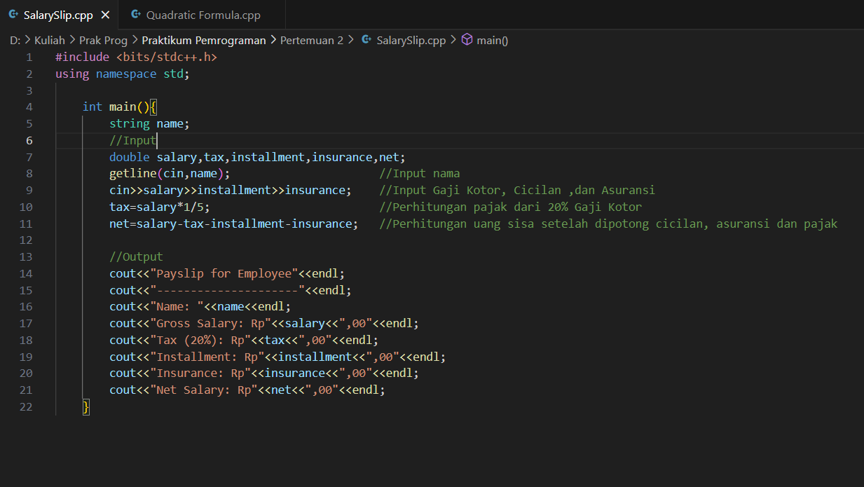

Test for Payslip Calculation (from Problem 1):

Test Case 1

Kenji Ratanaputra

1000000

100000

50000

Expected Output:

Payslip for Employee

---------------------

Name: John Doe

Gross Salary: Rp1000000,00

Tax (20%): Rp200000,00

Installment: Rp100000,00

Insurance: Rp50000,00

Net Salary: Rp650000,00

Test Case 2

Mark Zuckeberg

5000000

2000000

200000

Expected Output:

Payslip for Employee

---------------------

Name: Mark Zuckeberg

Gross Salary: Rp5000000,00

Tax (20%): Rp1000000,00

Installment: Rp2000000,00

Insurance: Rp200000,00

Net Salary: Rp1800000,00

Code untuk Mencari Persamaan Kuadrat

Test for Quadratic Equations (Problem 2)

* 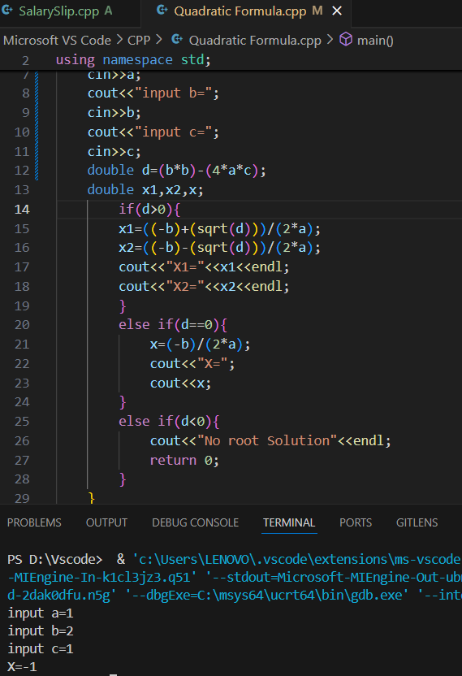If D=0

$x^{2}+2x+1$ =0; Expected Output = X=-1

a=1, b=2, c=1

=0; Expected Output = X=-2

a=4, b=16, c=16

* A screen shot of a computer program

  Description automatically generatedIf D>0

-2x-15=0; Expected Output = X1=5, X2=-3

a=1, b=-2, c=-15

6+5x-6=0; Expected Output = X1=0.666667, X2=-1.5

a=6, b=5, c=-6

* A screenshot of a computer program

  Description automatically generatedIf D<0

+x+1=0;Expected Output = No Root Solution

a=1, b=1, c=1